Offshore Wind Innovation Challenge (OWIC)

Appendix A Application Form Innovators

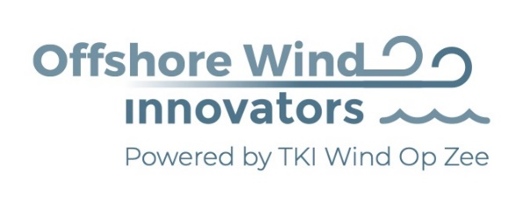

In partnership with
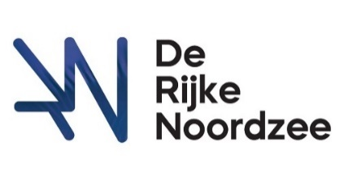

Organised By

Challenge | Name of the Challenge | Mark your challenge.  You can enter multiple challenges but each requires an individual entry form
1 | The perfect artificial reef
2 | Efficient biodiversity monitoring

Submission
You could submit your challenge by filling in this document and send you innovative idea + appendices to Maarten@echt.community before the 1st of September 2020. Excessive information about this challenge is formulated in the application form that is available for download at: https://www.offshorewindinnovators.nl/products/offshore-wind-innovation-challenge-2020
Application Form Innovators
Name Challenge
Name Innovator(s)
Type of organisation | SME / Start-Up / Engineer
Street
City + zip code
Country
Email
Phone number
Website
Description of solution
Benefits
Financial plan (costs, benefits) | Capex / Opex
Technology Readiness Level | 1, 2, 3, 4, 5, 6, 7, 8, 9
Patent applicable
Project Plan up till Bootcamp
Needs from Challenging Partners
Attachement(s)

