4th Offshore Wind Innovation Challenge (OWIC) 2020

Application Information Form Innovators
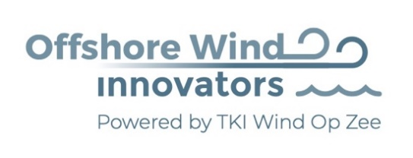

In partnership with

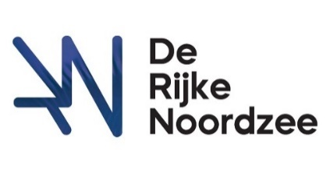

Organised By
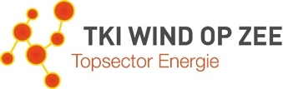

Content
1. Competition Introduction 3
Who are the sponsors of the 4th Offshore Wind Innovation Challenge? 3
What’s is in it for the innovators? 4
2. Challenge Set-Up 5
Preparation - COMPLETED 5
Application Phase – NOW 5
Pitch & Ask session – September 2020 5
Bootcamp November 2020 5
Offshore wind innovation Finals – January 2021 6
3. The Challenges 7
4. Clarifications and enquiries 9
Application process 9
Road to the Final 9
5. Supporting & Organising Partners 10

Competition Introduction
To construct one of the largest infrastructural developments in Dutch history, the offshore wind industry has to make offshore wind even more affordable, reliable and sustainable. Accelerating technical innovation and implementing it into the offshore market, will give the offshore wind industry a better position in the energy system, both in the Netherlands and internationally.
The Netherlands are known for their strong innovation skills, knowledge and experience in the wind and offshore industry. The 4th Offshore Wind Innovation Challenge is established for the Dutch offshore wind market, the offshore wind industry and start-ups from all over Europe. The Challenge aims to make offshore wind more affordable, giving offshore wind the best position in the energy system for the Netherlands, but also in international.
The aim of the challenge is to connect Innovators/Start-ups/SME’s with leading offshore wind organisations by presenting out of the box solutions to challenges put forward by these organisations.
The preparation of the challenge started in March 2020 with a call for leading companies to share their challenges/problems they faced during the development, installation, operations & maintenance or decommissioning phase. In this application form, we announce the challenges of the 4th Offshore Wind Innovation Challenge.
In addition, this document is the Offshore Wind Innovation Challenge KICK-OFF for all the Engineers, SME’s and start-ups, that are asked and supported to come up with innovative solutions for the challenges between May and September 2020. The solutions may range from concept ideas to applied solutions from other industries. Thereafter, the Pitch & Ask session, Bootcamp and Final will be organised to improve the innovations and select the Final winner of the Offshore Wind Innovation Challenge in January 2021.
This challenge has been launched to create an opportunity for SME’s and start-ups to show their innovative solutions that are requested by large companies also called sponsors in the offshore wind industry sector. This challenge is targeted at innovations that aim to be ready for (nearby) commercial implementation (within two years).

Who are the sponsors of the 4th Offshore Wind Innovation Challenge?
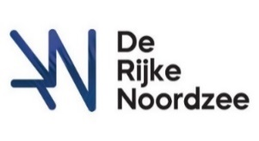
De Rijke Noordzee is a programme that aims to improve the underwater nature in offshore wind farms. They are active in 6 offshore wind farms with the development, installation and monitoring of nature enhancement projects. De Rijke Noordzee functions as the leading party that develops and integrates nature in offshore wind farms. They have a major community of contractors and developers that are collaborating and seeking nature enhancement in offshore wind farms.

What’s is in it for the innovators?
The innovators will have access to the following:
Coaching
Expert coaching and steering from the leading offshore wind companies during the Pitch & Ask session and Bootcamp. A successful introduction to the offshore wind market goes beyond the development of a technically perfect product or system. For innovators, it is key to understand the problem of the sponsor in depth to improve their initial presented solution.

Possible Launching Customer
The offshore wind market is a relatively new and dynamic sector. Many companies in this sector are searching for new partners. Innovative companies that want to conquer a position in this market have the opportunity to convince the leading offshore wind companies with their solution. The Offshore Wind Innovation Challenge facilitates the possibility to create partnerships and attract a launching customer.

Publicity support
Brand awareness and visibility are essential elements of a successful business. During the competition, we will use our flexible and customized communications packages, offering the participants access to media channels.

Challenge Set-Up

The Offshore Wind Innovation Challenge consists of 5 steps that are visualized in Figure 1. All steps are described in this chapter to inform you about the process. The first step is completed and the second step is up to you as innovators!
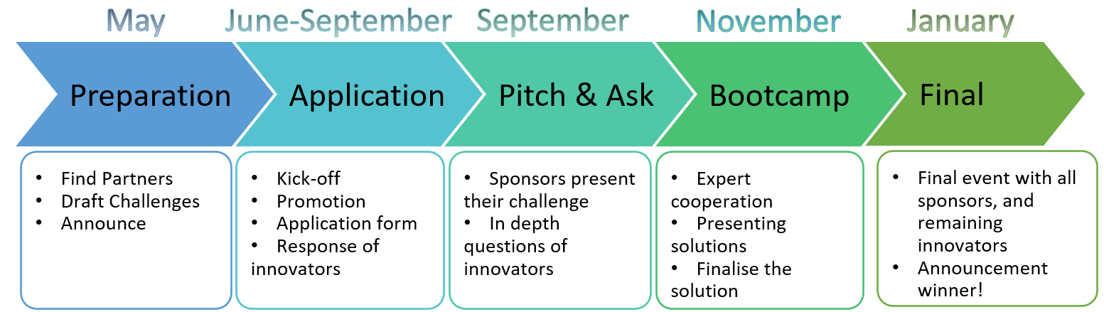
Figure 1 Offshore Wind Innovation Challenge Set-Up

Preparation - COMPLETED
The Offshore Wind Innovation Challenge sponsors drafted challenges that need an innovative solution. On May the 28th, the organisation, partners and sponsors will announce the 4th Offshore Wind Innovation Challenge via LinkedIn, websites and in their community. The announcement includes the challenges that are submitted by the sponsors, the application process and the timeline of the Offshore Wind Innovation Challenge.

Application Phase – NOW
Innovators like SME’s, engineers and start-ups can develop solutions for the challenges. You should hand in your proposals before the 1st of September 2020 using the submission form. There will be a fit for purpose scan executed by the organisation in order to pass the Pitch & Ask session. The proposals will be based on a fixed template, including rules of the game. One important criterion to become part of the Pitch & Ask session is to create a design or prototype of an innovative product or idea that can be implemented within 2 years and a demonstration type of animation available in January during the Finals.

Pitch & Ask session – September 2020
At the Pitch & Ask session a selected group of innovators are invited. During this meeting, the sponsors present their challenge to the innovators. Thereafter, the innovators will have the possibility to interview the sponsor by asking questions and to better understand the real question that needs to be solved.
At the end of the Pitch & Ask session, each of the innovators presents their vision and draft solution on the selected topic to the sponsors. The provisional date of the Pitch & Ask session is Friday the 25th of September between 13:00 and 17:00 at a yet unknown location in the Netherlands. There is an option to schedule this session online if the Covid-19 rules are recommending working from home. Out of these pitches, a maximum of 3 participants per challenge will be selected by the sponsor for the next phase.

Bootcamp November 2020
After the Pitch & Ask Session the innovators have time to improve their solutions for the Bootcamp. During the Bootcamp, innovators, sponsors and experts will collaborate to optimize the solution for the challenges in an interactive session. The provisional date of the Bootcamp is Friday the 20th of November between 13:00 and 17:00 at a yet unknown location in the Netherlands (online if needed because of COVID-19). At the end of this Bootcamp, a maximum of 2 participants per topic will be selected for the Final, after having pitched their idea to a jury.

Offshore wind innovation Finals – January 2021
During the Innovation Finals, all sponsors and the top of the offshore wind industry will be invited to see the presentations. The innovators will have the opportunity to present their ideas in a 10 minutes pitch for the public and a jury during the Finals. At the end of the event, the jury will select one winner.
There are multiple challenges, but only one overall winner is selected by the jury. However, other innovators and sponsors that are satisfied with the ‘losing’ innovations are encouraged to exchange contacts, start cooperation and further development of the innovation product. Because almost 4 out of 5 challenges found a solution and partnership through the first 3 Offshore Wind innovation Challenges.
The provisional date of the Final is in the second or third week of January 2021 at a yet unknown location in the Netherlands.

The Challenges
- The perfect biodegradable reef – De Rijke Noordzee
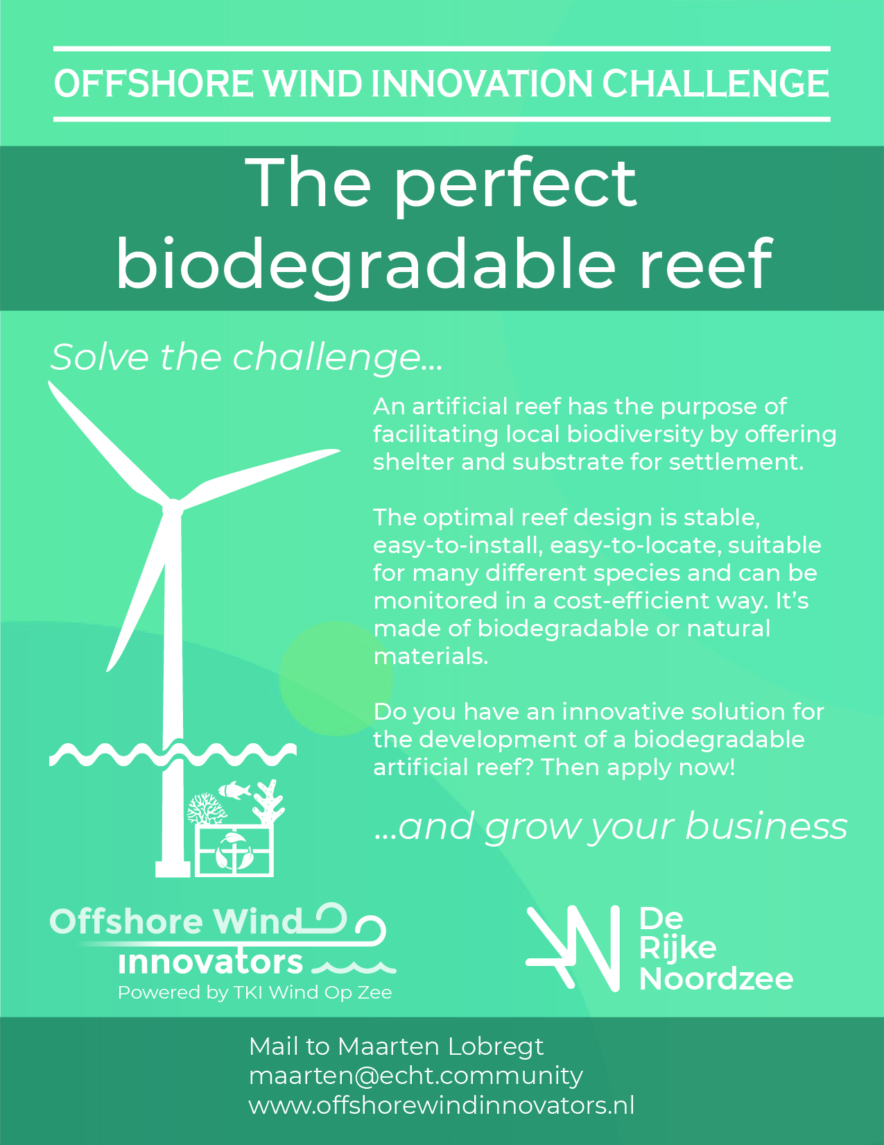
- Efficient biodiveristy monitoring – De Rijke Noordzee
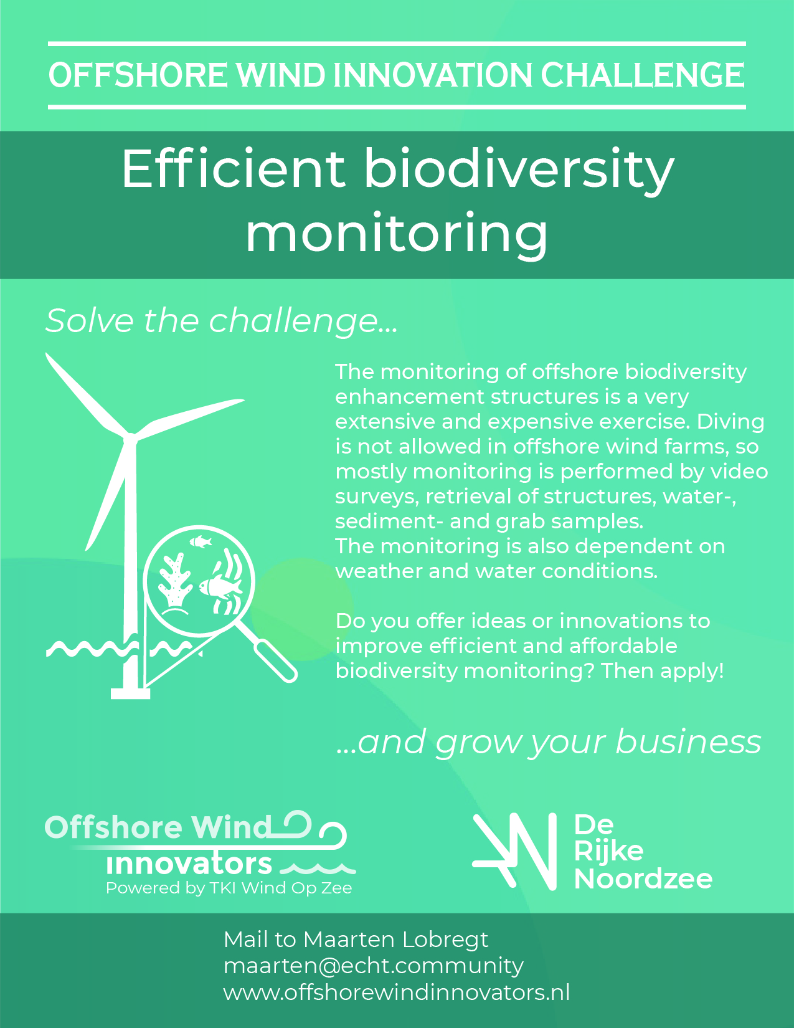

Clarifications and enquiries

Application process
As an innovator, you can now start with developing solutions for the presented challenges. You can submit your challenge via the application form that is outlined in Appendix 1. Your application should include an executive summary of not more than one page. In addition, it should provide a comprehensive overview of your proposed innovation that may include financial and technical details (preferably with a visualization of your idea).
You can find excessive information about the challenges at the website: https://www.offshorewindinnovators.nl/products/offshore-wind-innovation-challenge-2020
Your application and additional documentation should be submitted via e-mail to Maarten@echt.community
- No later than 17:00 CET time on 1st of September.
- A confirmation e-mail will inform you that your submission has been received. Innovators may submit multiple challenges. However, each solution must be submitted on a separate application form that is available in appendix A.

Road to the Final
The sponsors and organizers of the Offshore Wind Innovation Challenge will review your applications and select a large group for the Pitch and Ask session. The sponsors will give some further explanations of their challenge and it is up to the innovators to question the sponsors about their challenges. At the end of this session, the innovators should pitch their solution to the jury of sponsors and the organisation.
A selected group will be invited for the Bootcamp. At this event, each innovator gets the opportunity to discuss and develop their solution with the sponsor in a 1 on 1 session. The goal of this session is to create common ground and find the best fitting solution with the help of a specialist from the sponsor.
The jury of the challenge (including sponsors and organisation) will choose a select group to present their solution at the Finals.
Innovators will be updated with extensive instructions and information via e-mail at each phase.
Any questions or requests about the challenge should be sent to Maarten@echt.community

Kind regards,
The Offshore Wind Innovation Challenge team
Martin Weissmann, Erwin Coolen, Jacky Driessen, Angelita Kappers & Maarten Lobregt

Supporting & Organising Partners
TKI Wind op Zee
TKI Wind Op Zee facilitates R&D, demonstration, valorisation, knowledge transfer, collaboration, education and market development towards maximizing cost reduction and economic impact of offshore wind. As well they are organizing matchmaking events around projects than can apply for MOOI, HER and DEI subsidies.
https://topsectorenergie.nl/tki-wind-op-zee

Offshore Wind Innovators
Offshore Wind Innovators is a community for companies pioneering the Offshore Wind Industry. It is our goal to give insight into the business- and innovation ecosystem of the industry and it offers practical solutions to the business challenges that pioneering companies face. Offshore Wind Innovators is powered by TKI Wind op Zee.
https://www.offshorewindinnovators.nl/about
We help to introduce SME’s to a strong innovation network and develop products to help fund and market new products and ideas. Join our community and become a member:
https://www.offshorewindinnovators.nl/become-a-member

NWEA
NWEA unites the wind sector and accelerates the transition towards a renewable energy supply by spurring businesses and governments to invest in wind energy.

https://nwea.nl/

ECHT – Regie in transitie
ECHT is a transition bureau that assists public and private organisations in the energy transition. Our philosophy is that organisations will change due to the sustainable development goals (SDG’s) and national sustainability targets. Through our profession and help of our community, ECHT will assists companies to achieve their challenging sustainability goals. We take the lead in transition!

https://www.echt.community/

Offshore Wind Innovation Challenge (OWIC)

Appendix A Application Form Innovators

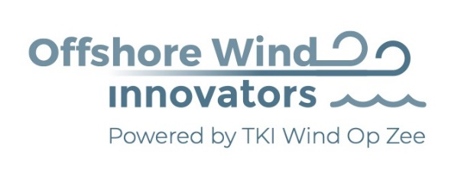

In partnership with

Organised By

Challenge | Name of the Challenge | Mark your challenge.  You can enter multiple challenges, but each requires an individual entry form
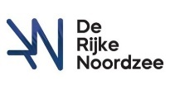  1 | The perfect artificial reef
2 | Efficient biodiversity monitoring

Submission
You could submit your challenge by filling in this document and send you innovative idea + appendices to Maarten@echt.community before the 1st of September 2020. Excessive information about this challenge is formulated in the application form that is available for download at https://www.offshorewindinnovators.nl/products/offshore-wind-innovation-challenge-2020
Application Form Innovators
Name Challenge
Name Innovator(s)
Type of organisation | SME / Start-Up / Engineer
Street
City + zip code
Country
Email
Phone number
Website
Description of solution
Benefits
Financial plan (costs, benefits) | Capex / Opex
Technology Readiness Level | 1, 2, 3, 4, 5, 6, 7, 8, 9
Patent applicable
Project Plan up till Bootcamp
Needs from Challenging Partners
Attachement(s)

